**Name:** Gunjan Jhawar

**Subject code:** EE 511

Simulation of Scholastic System

**USCID:** 1857534264

**Project: 2 and 3**

**Aim:**

1. Estimate:

* Pi by area method and,
* Confidence interval of the data
* Plot the graph of successive values of the estimator as the number of sample increases.
* How many points are needed to estimate pi within +- 1% of true value of pi with probability of 0.95.

1. Evaluate the integral:

C:\Users\GunjanJ\AppData\Local\Microsoft\Windows\INetCache\Content.Word\in.jpg

Taking n =1,2,3,4,5.

* Based on the above approach, evaluate the integral for n =10,100,1000:

C:\Users\GunjanJ\AppData\Local\Microsoft\Windows\INetCache\Content.Word\in.jpg

* Using the above result, can you comment on Dirichlet Integral:

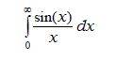

1. Find probabilities of different possible poker hands using Monte Carlo Approach.

**Software Used:**

MATLAB

**Procedure:**

1. Using ‘rand’ function, generate a vector of random numbers whose size is from 1 – 500. Another same size vector of random numbers is generated. They will be the coordinates of the square bounding the quadrant. The coordinates for quadrant is defined in terms of polar coordinates. The function ‘inpolygon’ is used to find the count of random numbers which fall in the quadrant [1].

Using this formula to estimate pi [2]:

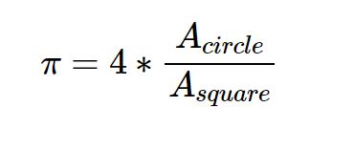

1. Expressing x in terms of y, we can convert sinx/ x to sinc function . Find the area under the curve for the sinc function for an interval of pi. Using function ‘trapz’ to find the area under the curve. Repeating the experimenting for different intervals of pi.

Then doing the experimenting for interval 0 – n*pi where n = 10,100 and 1000.

Then taking n approaching infinity and then calculating area under the curve.

1. Using ‘’randperm’ to randomly shuffle the deck of 52 cards. Picking out the first 5 cards from the vector and checking if there is a possibility of any hand. For finding the probability of a possible hand we used functions like ‘nchoosek’ and ‘factorial’ to select particular cards from the deck.

**Observation:**

1. When we do estimation of pi repeatedly for a couple of trials we see that our estimate of pi gets closer and closer to the true value of pi.
2. We observe that as n increases for the function the value of the integral reaches pi/2..
3. We observe that the probabilities to find a no pair card is highest while to find a royal flush the least.

**Analysis of Experiment:**

1. Monte Carlo Experiments are a broad class of computational algorithms that rely on repeated random sampling to obtain numerical results [3].

The confidence interval for a population proportion to show the statistical probability that a characteristic is likely to occur within the population [4].

The formula for a CI for a population proportion is:

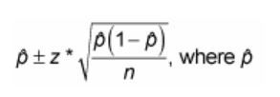

is the sample proportion,*n*is the sample size, and *z\** is the appropriate value from the standard normal distribution for your desired confidence level. The following table shows values of *z\** for certain confidence levels.

1. The integral is not convergent, and so the integral is not even defined in the sense of Lebesgue integration, but it is defined in the sense of the improper Riemann integral [5]. Also, by mathematically proof that the result is pi/2 [6].

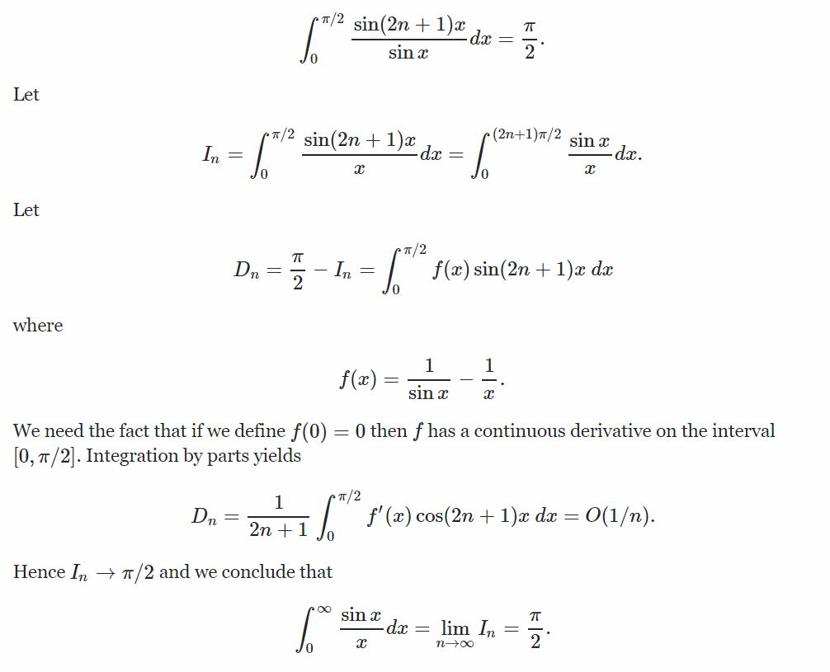

1. Different kinds of poker hands are [7].

**Relevant Graphs:**

A.



Estimate of pi 1

B.

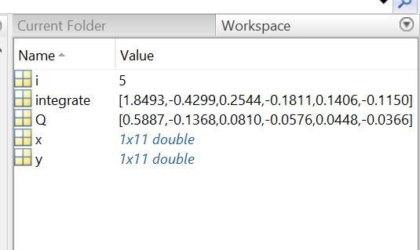

Value of sinx/x for n =1,2,3,4,5

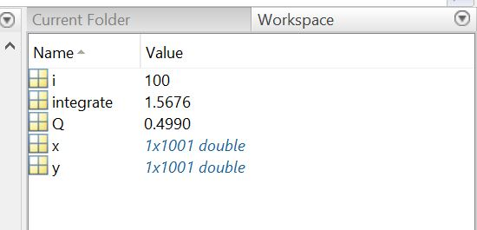

For n=100

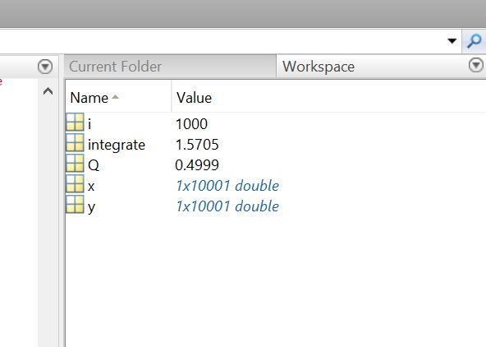

For n = 1000

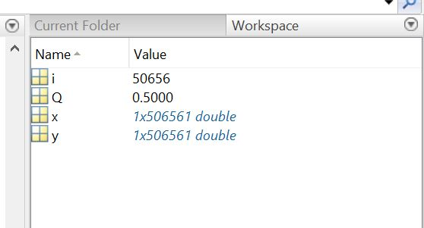

For large n

C.

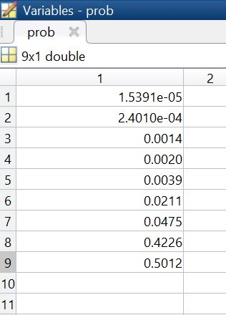

Probability of poker hands

**Conclusion:**

**A.**  The value of pi is approximately 3.14.

**B.** The value of dirchilet integral is pi/2.

**C**. Different poker hands has different probabilities and as constraint increase the probability to get that hands becomes tougher.

**References:**

1. https://www.youtube.com/watch?v=M34TO71SKGk&t=207s
2. http://maciejczyzewski.me/2015/01/10/monte-carlo-method-calculating-pi.html
3. https://en.wikipedia.org/wiki/Monte_Carlo_method
4. http://www.dummies.com/education/math/statistics/how-to-determine-the-confidence-interval-for-a-population-proportion/
5. https://en.wikipedia.org/wiki/Dirichlet_integral
6. https://math.stackexchange.com/questions/5248/evaluating-the-integral-int-0-infty-frac-sin-x-x-dx-frac-pi-2
7. http://www.cardplayer.com/rules-of-poker/hand-rankings